BIOL 2510 Learning Objectives 3CD

Lecture 3C
- Draw the process of activation of a naïve B cell against a T-dependent antigen. Show the surfaces of the two cells involved and label the following: MCH I, BCR, CD4, TCR, and the antigen. In your drawing, show how the B cell takes in and processes the antigen. Photograph your drawing and insert it here
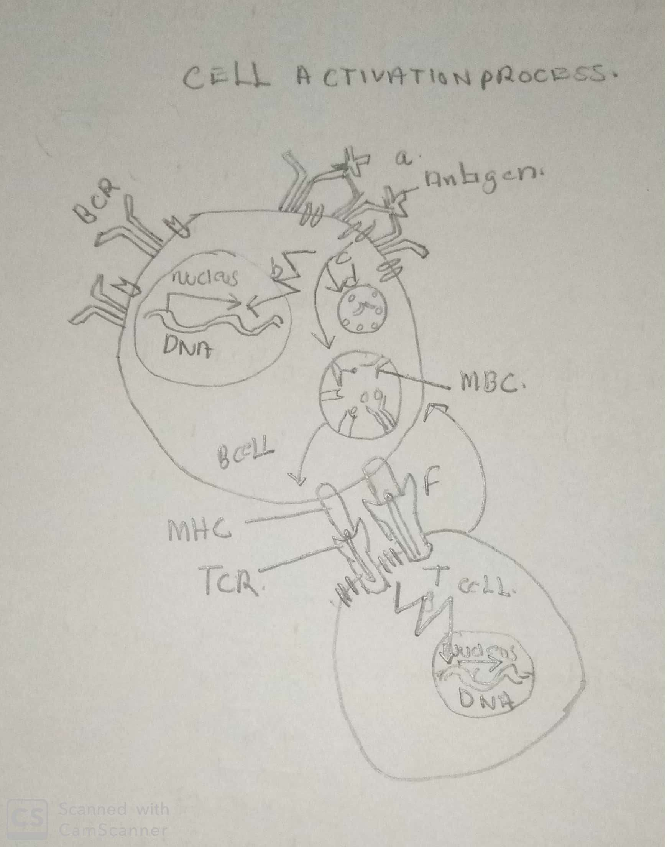

- Describe the function of the effector cells and memory produced by the clonal expansion and differentiation of an activated B cell.
Effector cells produce protein antigens while memory help T cells in their activity

- Differentiate between the activation of B cells to T-dependent antigens versus the activation of B cells to T-independent antigens concerning the chemical nature of the antigens and the production of memory B cells during clonal expansion and differentiation.

T-dependent antigens can stimulate B cells to become activated but require cytokine assistance delivered by helper T cells. T-independent antigens can stimulate B cells to become activated and secrete antibodies without assistance from helper T cells.

- Describe these antibody functions: precipitation, agglutination, neutralization, opsonization, and complement fixation.
Precipitation is the process of transforming a dissolved substance into an insoluble solid from a super-saturated solution.
Agglutination is defined as the formation of clumps of cells or inert particles by specific antibodies to surface antigenic components
Neutralization is the process where antibodies inactivate bacterial toxins or virus particles by binding to their component antigen molecules.
Opsonization is an immune process that uses opsonins to tag foreign pathogens for elimination by phagocytes.
Complement fixation is the process of binding serum complement to the product formed by the union of an antibody and the antigen for which it is specific that occurs

- Describe the process of class switching by a plasma cell and its effect on antibody structure and the antigen specificity of the antibodies produced.

The cell class switches to change the type of immunoglobulin it is producing. The B-cell produces the membrane-bound B-cell receptor (BCR) while the plasma cell produces the secreted form of I, the antibody. Now, the isotypes are different in their constant regions and I'm assuming switching only matters if it is an antibody.

- Describe the structure and functions of each of the five antibody classes, MADGE.
IgA- It contains an alpha-heavy chain. It is present in colostrum, and has an important role in passive immunization of infants, exists as a dimer. Also secreted through tears & saliva. The plasma level is around 13%.
IgD- It is formed of a delta heavy chain. It serves​ as B cell receptors.
IgE- Formed of epsilon heavy chain. It is present in scarce in the plasma, it is the antibody of allergy, generally binds to basophils and mast cells.
IgG- Formed of gamma heavy chain. It is abundant in plasma(80%), and also the smallest in size. Due to its smaller size, it can pass through the placental barrier and provides passive immunization to the fetus. Generally binds with phagocytes. Neutralizes toxins and carries opsonization. Responsible for erythroblastosis fetal in Rh- mother.
IgM- Formed of mu heavy chain. Largest of all serves as B cell receptors. It is the main antibody for a primary response. Present in plasma around 6%.

- Contrast natural and artificial modes of passive and active immunity and give examples. (Table provided)
Passive Immunity: Antibodies enter the blood of an individual, but they are not produced by the immune system of the individual. No memory cells are formed.
 | Natural Passive | Antibodies from the mother cross the placenta into the fetal individual’s blood.  Antibodies from the mother are present in breast milk. They enter the infant individual’s digestive tract and are absorbed into the blood.
 | Artificial Passive | Antibodies collected from one to several persons are injected into the body of an individual.
Natural Immunity: An antigen triggers the production of antibodies by the immune system of an individual. Memory cells are formed.
 | Natural Active | Antigen enters the body naturally by way of infection to cause a primary response and possibly a secondary response later.
 | Artificial Active | The antigen is injected into the body by way of vaccination to cause a primary response and possibly a secondary response later.

- Differentiate between the primary immune response and the secondary immune response concerning speed, amount of antibodies produced, the affinity of antibodies for antigens, and the role of memory cells.
In a primary immune response, naive B cells are stimulated by antigen, become activated, and differentiate into antibody-secreting cells that produce antibodies specific for the eliciting antigen. A secondary immune response is elicited when the same antigen stimulates memory B cells, leading to the production of greater quantities of specific antibodies that are produced in the primary response. Some of the differences between Primary and Secondary Immune Response are as follows

- Describe the roles of macrophages and helper T cells in the integration of the innate and adaptive immune responses.
Macrophages work as innate immune cells through phagocytosis and sterilization of foreign substances such as bacteria, and play a central role in defending the host from infection while Helper T cells are arguably the most important cells in adaptive immunity, as they are required for almost all adaptive immune responses. They not only help activate B cells to secrete antibodies and macrophages to destroy ingested microbes, but they also help activate cytotoxic T cells to kill infected target cells.

- Relate various ways immune responses are kept in check.

Antibodies attach to a specific antigen and make it easier for the immune cells to destroy the antigen. T lymphocytes attack antigens directly and help control the immune response. They also release chemicals, known as cytokines, which control the entire immune response.

- Define autoimmunity and briefly describe the five theories as to its cause.
Autoimmunity is the system of immune responses of an organism against its healthy cells, tissues, and other body normal constituents. • Thymus gland defect theory suggests that some self-antigens are not presented to T cells during the fetal stage due to a defect in the thymus gland. Generalized autoimmune disorders like serum lupus erythematosus (SLE) may be produced in this way.
Defective lymphocyte theory suggest that Suppressor T cells decrease in number or activity some lymphocytes fail to respond to suppressor T cell cytokines some defective or self-intolerant B cells produce autoantibodies

Genetics theory suggests that Females are at higher risk for autoimmune disorders than males. Abnormally high or low serum levels of certain cytokines occur in autoimmune disorders, reflecting abnormal gene expression. Certain MHC alleles are associated with autoimmune disorders.
Antigenic mimicry theory suggests that infective agents deposit molecules on host cells during infection. Later an immune response is directed against those cells. Guillain-Barre Syndrome often develops following Campylobacter jejuni infection. Rheumatic heart disease often develops following streptococcal infection.
Sequestered antigen theory suggests that some self-antigens (cornea of the eye or spermatogenic cells in the seminiferous tubules of the testis) are normally hidden from the immune system throughout life so developing lymphocytes do not develop self-tolerance toward them. If exposed due to injury, autoimmunity results.

- Describe the mechanisms of action of the four classes of immunosuppressive drugs.

The prevailing paradigm regarding the mechanisms of action of immunosuppressants is that they all function to prevent allograft rejection by preventing/inhibiting cell activation, cytokine production, differentiation, and/or proliferation

- Describe, step-by-step, a Hypersensitivity Type I reaction and give examples of triggers and related disorders.
Hypersensitivity Type I a form of “immediate” hypersensitivity. A reaction occurs within 10-30 minutes after exposure to an allergen. An allergen is a chemical that is not harmful to the body, but the immune system treats it as a foreign antigen. The immune system becomes sensitized to an allergen through B cell activation and the production of IgE antibodies by plasma cells. IgE then binds to mast cells and basophils. Those cell types have membrane receptors for IgE stems (Fc receptors). Subsequent exposure to the same allergen will cause the allergen to bind to and crosslink IgE on basophils and mast cells. This signals cytoplasmic changes (increased intracellular Ca2+ ions, etc.) that lead to degranulation==secretion of histamine.
It can be triggered by Substances like medications, insect stings, foods, pollens, various inorganic chemicals.

- Describe, step-by-step, a Hypersensitivity Type II reaction and give examples of triggers and related disorders.
The response is usually "immediate", but in some cases (thyroiditis or myasthenia gravis) it can occur over a longer period. It is an antibody-mediated reaction against proteins on the surface of donor human cells or in some cases, self cells. Inflammation can be excessive or absent.
Initial exposure to the antigen activates B cells that become IgG and IgM secreting plasma cells. The antibodies then bind to the antigens on the foreign cells or self cells. There are three possible results: Inflammation mediated by complement or Fc receptors acute rheumatic fever (streptococcal antigens mimic myosin in cardiac muscle fibers) Transfusion reaction (ABO mismatch) See diagram below. Cell depletion or destruction without inflammation autoimmune hemolytic anemia autoimmune thrombocytopenia hemolytic Disease of the Newly Born (Erythroblastosis fetalis) cell dysfunction due to antibody binding myasthenia gravis; antibodies bind to nicotinic receptors for acetylcholine at the motor endplate of skeletal muscle fibers. Muscle weakness occurs. See diagram below. Graves disease; antibodies bind to thyroid-stimulating hormone receptors on thyroid follicle cells. Thyroid hormone level is very low (hypothyroidism).

Lecture 3D
- Describe, step-by-step, a Hypersensitivity Type III reaction and give examples of triggers and related disorders.
Antigen-antibody complexes form but are not cleared by phagocytes. They become lodged in tissues, complement is activated by the classical pathway and Inflammation is prolonged. The reaction is not immediate. It peaks at about 6 hours post-exposure. The reaction is mediated by IgG and IgM, complement, and innate immune cells (neutrophils and mast cells). Antigens fall into three categories: microbial molecules, inhaled environmental (mold, plant, animal) molecules, and self molecules that provoke autoantibody formation. Type III antigens are NOT cellular. Type III antigens are precipitated by antibodies and then deposit in tissue. The type III inflammatory response to the antigen-antibody complexes formed from microbial or inhaled antigens causes the exposure of autoantigens in damaged tissue. B cells react by forming autoantibodies thus creating even more antigen-antibody complexes.
Hypersensitivity Type III is triggered by Antibodies are formed against streptococcal or staphylococcus bacterial antigens following a kidney infection. Complexes become lodged in glomerular capillary basement membranes of kidney nephrons and cause inflammation there.

- Describe, step-by-step, a Hypersensitivity Type IV reaction and give examples of triggers and related disorders.
A delayed reaction occurs and peaks 24 hours to 14 days postexposure. Early in the reaction mast cell degranulation causes recruitment of macrophages and T cells. Neutrophils, B cells, and antibodies are NOT involved. Symptoms are usually confined to the skin. Contact hypersensitivity is the most familiar form of type IV reaction. It occurs as a reaction to haptens (“half antigens”). Haptens are lipid-soluble molecules and thus can penetrate the epidermis of the skin after being touched. Haptens are associated with various plant oils (poison ivy), cosmetics, latex, elastics, adhesives, ointments, metals (nickel), etc. Haptens become antigenic in the dermis of the skin by binding to a self protein. Resident dendritic cells (Langerhans cells) and interpret the hapten/self protein as a foreign antigen. Dendritic cells migrate to lymph nodes and present the "antigen" to activate helper T cells. Upon subsequent exposure to antigen memory, helper T cells mediate a response. The result is a red, blistery, itchy rash! The reaction begins to subside at about 72 hours. Cutaneous basophil hypersensitivity occurs in the immune rejection of skin grafts. It is the fastest form of type IV hypersensitivity, peaking at 24 hours after exposure. It is mediated by Helper T cells that release cytokines to recruit basophils. The reaction usually lasts 7-10 days. • Tuberculin-type hypersensitivity is the basis for the Mantoux skin test for tuberculosis. If a person previously exposed to TB receives a dermal injection of TB antigen, a skin reaction similar to a contact hypersensitivity response occurs. The amount of antigen injected is very small so the reaction is usually mild and short-lived. • Granulomatous hypersensitivity is a chronic type IV hypersensitivity mediated by lymphocytes and macrophages against antigens that cannot be cleared by phagocytes.

- Describe two reasons for the failure of phagocytosis that leads to granuloma formation.
Phagolysosome formation does not occur, as in tuberculosis and leprosy (both due to intracellular Mycobacteria infections). • The antigen survives the lysosomal enzymes of the phagocyte, as in reactions to talc and certain suture materials hence leading to granuloma formation.

- Contrast the primary immunodeficiency disorders: SCIDs, Wiskott-Aldrich Syndrome, DiGeorge Syndrome, chronic mucocutaneous candidiasis, IgA deficiency, and Bruton X-Linked Agammaglobulinemia concerning etiology and clinical manifestations. (Table provided)
Disorder | Etiology | Clinical Manifestations
T-B+NK- SCID | IL2R (IL2 receptor) gene mutation (X-linked)  JAK3 (Janus kinase) gene mutation (autosomal)  In both cases, IL2 receptor function is impaired. Activation of T cells is impaired. | Patients are extremely susceptible to opportunistic infections, most commonly: Candida albicans, Pneumocystis carinii, cytomegalovirus (CMV), herpes virus, varicella (chickenpox) virus, and measles virus. Infections are medical emergencies due to the risk of sepsis. Protective isolation of SCID children is advisable.
T-B-NK+ SCID | RAG1 or RAG2 gene mutation  In both cases antibody, BCR and TCR diversity are limited. T cell and B cell responses are limited to very few antigens. | As above
T-B-NK- | ADA (adenosine deaminase) gene mutation; naïve T4 cell conversion to effector T4 cell is impaired.  AD2 (adenylate kinase) gene mutation; a most severe form of SCID (reticular dysgenesis); neutrophil activity is also affected. | As above
T-B+NK+ | IL7R gene mutation; IL7 receptor activity is impaired. | As above  Not as severe as other forms.
Wiskott-Aldrich Syndrome | WAS gene (X-linked) mutation; impaired cytoskeleton organization in T cells and B cells resulting in Abnormal antibody production and antibody type switching in plasma cells.  IgM levels are low and the levels of the other antibody types are either high or low.  T cells are present but have low activity.  Thrombocytopenia, but the relationship to the WAS gene is unknown. | Males are affected by:  Eczema (dermatitis)  Purpura (flat red skin patches due to dermal bleeding)  Infections: pneumonia, meningitis, otitis media, sepsis  Renal disease, malignancy, systemic autoimmunity
DiGeorge Syndrome | Partial deletion of the long arm of chromosome 22; thymus gland is very small or absent; T cell development is impaired | Recurrent infections  Non-immune effects:  developmental delay, cardiac anomalies, hypoparathyroidism with hypocalcemia, hypothyroidism, esophageal atresia, urogenital anomalies, abnormal facial features
Chronic Mucocutaneous Candidiasis | Mutation in the gene for IL17 or IL17 receptor; individuals are unable to respond to antigens associated with Candida albicans (yeast) | Severe skin and mucous membrane yeast infections occur. Skin infections cause disfigurement.
IgA Deficiency | Autosomal recessive and autosomal dominant forms exist, but the gene has not yet been identified. Plasma cells cannot produce IgA. Production of anti-antibody antibodies is heightened (autoimmunity) | Body tract infections  (IgA is the secretory antibody. It is normally produced by B cells in the lymphoid nodules that reside in body tract walls.)
Bruton X-Linked Agammaglobulinemia | Btk (Bruton tyrosine kinase) gene mutation on the X chromosome; B cell numbers and IgG are very low. IgM and IgA are absent. Helper T cell numbers are low; lymphoid tissues are poorly developed. | Males are affected by:  Recurrent infections most often by Streptococcus pneumoniae and Haemophilus influenza: pneumonia, meningitis, otitis media, sinusitis, sepsis.  Adults with XLA experience a high risk of lung disease and arthritis.

- Describe the various causes of secondary immunodeficiency disorders.
Secondary Immunodeficiency may be due to physical, psychosocial, nutritional, environmental, or pharmacologic factors.
Excessive neuroendocrine response to stress (corticosteroid release) increases the risk of infection but decreases the risk of autoimmunity. Defective neuroendocrine response to stress decreases the risk of infection but increases the risk of autoimmunity.
Major surgery depresses the bone marrow for about a month.
Removal of the spleen reduces the response to encapsulated bacteria (S. pneumoniae, H. influenza, S. aureus).
Diseases such as diabetes, cirrhosis, severe burns, severe trauma, sickle cell anemia, malignancies, and severe infections can cause secondary immunodeficiency.
Cancer chemotherapy and radiation therapy kill rapidly dividing cells (bone marrow cells), so immune responses become deficient.
Drugs: anesthetics, alcohol, antibiotics, antithyroid, anticonvulsants, antihistamines, and steroids have been linked to secondary immunodeficiency.
Malnutrition: protein and calorie depletion, vitamin deficiency, mineral deficiency (zinc)
- Correctly label a diagram of HIV.

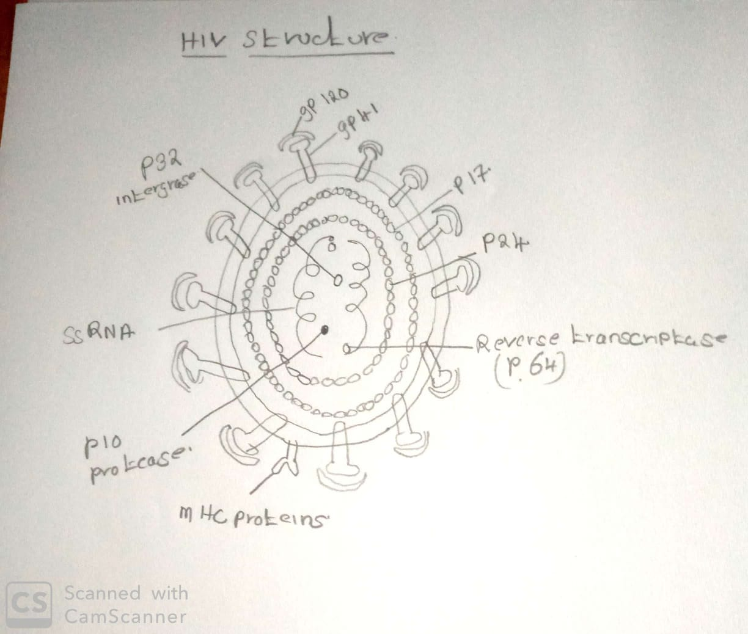

- Describe, step-by-step, the infection of a CD4 cell by HIV at the molecular level.
gp120 viral envelope protein binds to CD protein on the WBC membrane. gp120 changes the shape and binds chemokine receptors (CCR5) on the WBC membrane. Gp41 viral envelope protein implant itself into CB 4 membrane. Viral envelope and CB 4 fuse and virus core enter the cell.

- Describe, step-by-step, the HIV life cycle at the molecular level.

Reverse transcriptase converts viral +RNA into viral DNA. 2. Viral DNA enters the nucleus. 3. Integrase splices the viral DNA into the host cell's DNA. Viral DNA replicates along with host cell DNA. 4. Viral DNA is transcribed into new viral +RNA molecules. 5. Some viral RNAs are translated into viral proteins; others become part of new virus cores. 6. The viral protease cleaves new viral proteins into smaller sizes. 7. New virus particles are assembled, each including a piece of host cell plasma membrane as its envelope. 8. New virus particles bud from the surface of the host cell.

- Describe the transmission of HIV.

HIV is acquired primarily through sexual transmission via semen and vaginal or cervical secretions, parenteral transmission via blood by a transfusion of blood or blood products, or sticks with contaminated needles. Perinatal transmission from mother to child during pregnancy, during birth, or after birth (through breast milk) also occurs.

- Describe multiple mechanisms by which gp120 is involved in killing CD4 cells at the molecular level.
The infection produces huge numbers of progeny viruses. The gastrointestinal tract is the major site of HIV reproduction (inside lamina propria CD4+ cells). gp120 and gp41 are coated with carbohydrates (glycosylated). This makes HIV appear as “self” to some immune cells.CD4+ cell death may occur by several routes: Loss of cell membrane due to viral budding. Loss of normal host cell protein synthesis Attack by cytotoxic T cells or NK cells Effects of HIV gp120 (most common cause of death) υgp120 is shed from the virus surface and induces massive anti-gp120 synthesis. gp120 then binds to CD4 on uninfected cells; anti-GP antibodies bind to the GP 120. gp120s on the surface of the one HIV particle can bind to multiple CD4s on the same cell cause crosslinking of neighboring CD4 molecules. This cross-linking triggers apoptosis. Apoptosis is the major gp120 mechanism of CD4+ cell death in HIV infection.gp120 on budding viral particles binds to CD4 on its current host cell causing the host cell plasma membrane to tear. Simultaneous binding of gp120 on the surface of a single budding virus to CD4s on multiple uninfected cells can cause the formation of a fused mass of infected and uninfected CD4+ cells called a syncytium. Cell fusion and cell death follow.

- Describe the progression of HIV infection to the point of an AIDS diagnosis.
Incubation occurs during the weeks or months after HIV infection, the patient is usually asymptomatic. The infection is not picked up by lab tests, because anti-HIV antibodies have not yet formed. The virus is rapidly replicating and killing CD4+ cells in mucosal membranes, especially those in the digestive tract.
Seroconversion occurs 3 weeks to 6 months after infection when anti-HIV antibodies are detected in the blood. By this time, the patient feels ill with flu-like symptoms. A rash may be present. The CD4+ T cell count is greater than 400 cells per microliter (ul). Normal is 500-1500/ul. The CD8+ T cell count is usually elevated. Total WBC is depressed and platelets are depressed. The sed rate is high. HIV is present in high numbers in blood and genital fluids.
Latency occurs 1 to 4 weeks after seroconversion. The symptoms disappear, but the person is still infective. HIV is in the lymphatic tissues gradually destroying them. The immune system has mounted an antiviral response, so the virus is less active. The lymph nodes are enlarged due to the immune response. The CD4+ T cell count is still above 400/ul. Latency can last anywhere from 3 to 12 years. The symptomatic chronic phase, a period of rapid viral production lasting up to 18 months, ends the latency period. The lymph nodes have been destroyed and the virus has escaped into the bloodstream (viremia). The immune system’s antiviral response weakens as the CD4+ T cell count declines below 400/ul. Severe skin and mucous membrane infections occur.

- Describe the clinical manifestations of AIDS including the diagnostic CD4 count.

The most significant systemic symptom is wasting. It is due to a combination of effects: anorexia, malabsorption, and elevated metabolic rate. Other systemic effects: fever, chills, headache, nausea, diarrhea, vomiting, fatigue, weakness, sore throat, stiff neck, aching joints, rash. Everybody system experiences opportunistic infections. Pneumocystis pneumonia is a common killer. Kaposi sarcoma is cancer commonly associated with AIDS. Neurologic manifestations include peripheral neuropathy, dementia, headache, apathy, and other mental/emotional deficits. Children with HIV experience physical and mental developmental delays.

- Describe the blood test for HIV at the molecular level.
HIV tests are based on the reaction between test kit antibodies that bind to anti-HIV antibodies in the patient’s serum or saliva. An ELISA test for HIV uses purified HIV protein applied to plastic beads or placed in a well on a small plastic tray. The subject’s serum or saliva is applied to the beads or placed in the well with the HIV protein. In a positive test anti-HIV antibodies from the subject’s serum or saliva bind to the HIV protein. Then special antibodies direct against human antibodies are applied. To the beads or the well. If the “anti-human antibody” antibodies bind to the subject’s bound anti-HIV antibodies there is a color change or fluorescence occurs.

- Explain, at the molecular level, why there is no HIV vaccine yet.

Reverse transcriptase inhibitors block the conversion of viral RNA to DNA. Protease inhibitors block the processing of viral proteins. Integrase inhibitors block the integration of viral DNA into host DNA. CCR5 antagonists block binding of HIV to WBC surface.

